**PROPOSAL**

**Zookeeper System Enhancements**

**Version 1.1.2**

**Prepared by**

**Group 8**

Harmanpreet Kaur

Duy Phuc Tran

Viet Duc Hoang

1. Table of Contents

1. Stakeholders 4

1.1. Team members 4

1.2. Client 4

1.3. Supervisor 4

1.4 Unit Coordinator 4

2. Document revision 5

3. Term of References 5

3.1. Zoodata 5

3.2. Zookeeper 5

4. Rationale 6

5. Scope and objectives 7

5.1 Scope 7

5.2 Objectives 7

5.3 Out of Scope 7

6. Project Approach 7

6.1 Approach justification 7

6.2 Project model 7

6.3 Project plan 7

7. Skill and knowledge involved 8

8. Cost 9

9. Abbreviation 9

10. References 9

# Stakeholders

## Team members

|  |  |  |  |  |
| --- | --- | --- | --- | --- |
| **Student ID** | **Name** | **Phone**  **Number** | **Email** | **Master’s degree** |
| 10477967 | Harmanpreet Kaur  (Developer) | 0470 202 305 | harman11@our.ecu.edu.au | Cyber Security |
| 10418791 | Phuc Duy Tran (Developer) | 0433 945 262 | dptran@our.ecu.edu.au | Computer Science |
| 10489643 | Viet Duc Hoang (Leader) | 0402 735 823 | hducviet@our.ecu.edu.au | Computer Science |

## Client

|  |  |
| --- | --- |
| Name: | Robyn Hulkin |
| Email: | Robyn.Hukin@zoodata.com.au |
| Phone number: | 9845 0725 |
| Office: | Exchange House, Level 3, 68 St Georges Tce, Perth |

## Supervisor

|  |  |
| --- | --- |
| Name: | Jinho Jang |
| Email: | jjang@zoodata.com.au |
| Phone number: | [require] |
| Office: | Exchange House, Level 3, 68 St Georges Tce, Perth |

## Unit Coordinator

|  |  |
| --- | --- |
| Name: | Brianna O’Shea |
| Email: | b.oshea@ecu.edu.au |
| Phone number: | (08) 6304 5521 |
| Office: | Building 18, Room 309, Edith Cowan University (Campus Joondalup) |

# Document revision

|  |  |  |  |
| --- | --- | --- | --- |
| **Version** | **Date** | **Changes description** | **Author** |
| 1.0.0 | 8/8/2020 | Prepare document structure | Viet |
| 1.0.1 | 8/8/2020 | Added stakeholder table  Added term of references | Viet |
| 1.0.2 | 8/8/2020 | Added document revision | Viet |
| 1.0.3 | 8/8/2020 | Added Zookeeper description | Viet |
| 1.1.0 | 9/8/2020 | Update document structure | Viet |
| 1.1.1 | 9/8/2020 | Added scope and objective, project approach, skill and knowledge involved, cost, abbreviation and references | Viet |
| 1.1.2 | 9/8/2020 | Update team member information | Viet |
| 1.2.0 | 11/8/2020 | Update subheadings | Nathan |
| 1.2.1 | 11/8/2020 | Added aims, objectives and background of study | Nathan |

# Term of References

## Zoodata

**Zoodata** is an IT solution provide with twenty-one years of experience, founded in Perth, Western Australia and cooperates within different sectors and departments including health, government and corporates. With extensive experiences and rich expertise, Zoodata poses to be a major IT pioneer and trusted partner in Perth.

## Zookeeper

**Zookeeper** is web application and it was designed to replace the timesheet system which as still utilized by the client. The previous timesheet system called **Task Tracker**. Currently, the new timesheet system, Zookeeper is still in development stages and require to add more feature into its system.

1. Rationale

[ More detail about the current Zookeeper system ]

[ Add a diagram of Zookeeper system ]

|  |  |  |  |
| --- | --- | --- | --- |
| **Identify Objective** | **Current situation** | **Desire outcome** | **The gap** |
|  |  |  |  |
| **Action & Requirement** | | | |
|  | | | |

1. Aim of the project

The aim of the project is to create a website system that allow users to manage the tasks by creating, updating and deleting tasks and to replace the existing timesheet system called Time Tracker which as still utilized by the client.

1. Objectives of the project (Need to be improved)

The objectives of the project will be to:

- Develop a website application using C#, Blazor, EntityFramework, mySQL; and to

- Manage timesheet through; and to

1. Background of the study (Still need to be paraphrased and cited)

Before companies begin using timesheets, time periods are defined in the system. Most have a self-service module for employees to enter their time after supervisors set up parameters. These may include the work week, shift hours and overtime categories. Once these parameters are set, each employee receives login information.

Timesheets are a way to avoid illegal or lost information connected to these positions. Even when contractors work seasonally or at multiple locations, one centralized time tracking module can help to secure accurate payroll data.

Tracking time accurately, whether for regular employees, mobile workers or contractors, helps to reduce payroll costs. Employers have a more efficient system for each category of workers. They have a visual representation of what it takes to have a productive labour force.

1. Review of literature (Harry’s)

- Module 2 & 3 will explain more about this. Please have a look.

1. Project schedule (Viet’s)

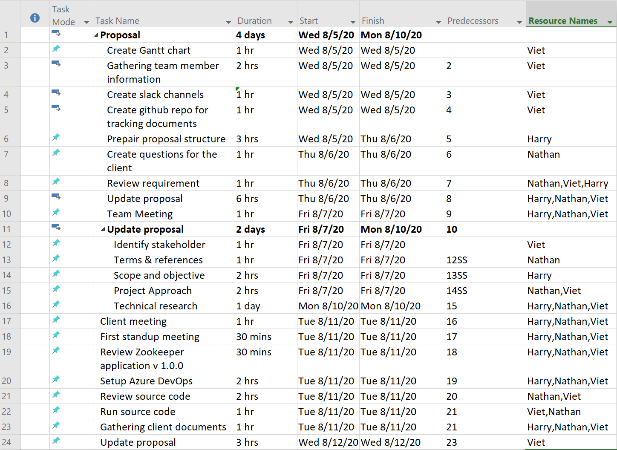

Figure Gantt Chart

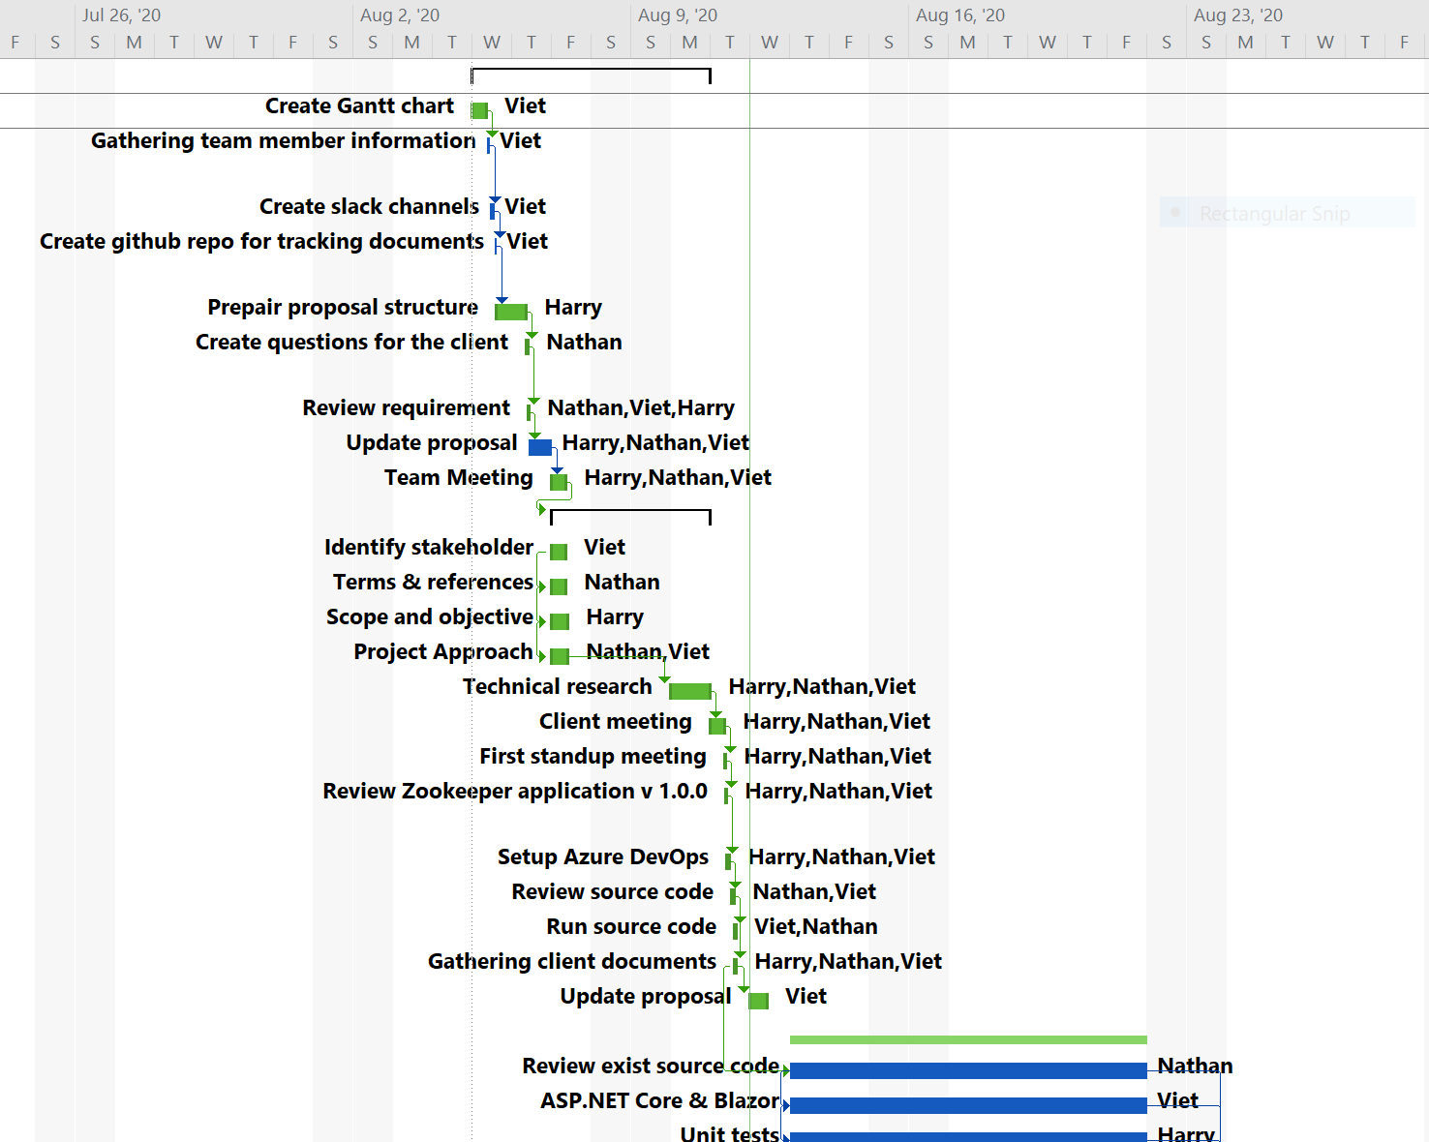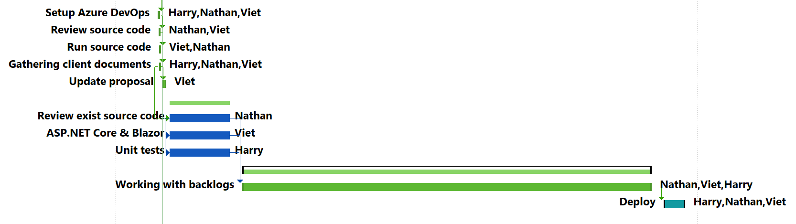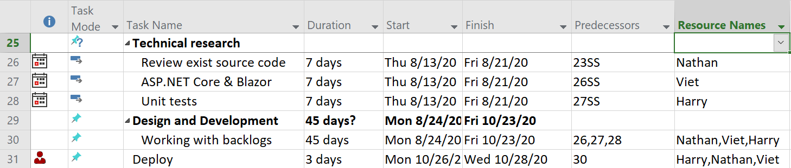

1. Proposed methodology (Phuc’s)

- Explain the step need to do

1. Expected outcomes (Harry’s)

- What we expect to achieve

1. Skill and knowledge involved

|  |  |  |
| --- | --- | --- |
| **Developers** | **Personal skills** | * Analytical skills * Teamwork skills * Self-learning * Workspace adaption * Communication skills * Strong written * Critical thinking * Research skills |
| **Project Management skills** | * Learning methodologies * Understand SDLC * Leadership * Team management * Negotiation skills * Well-organization skills * Risk management * Planning skills * Quality management * Problem solving |
| **Professional skills** | * Web development. * Design pattern. * C# and ASPNET Core. * SQL * HTML, CSS and Javascript * Graphic design UI/UX * Unit test. * Testing process. * Fix bug technique. |

1. Cost
2. Abbreviation

|  |  |  |
| --- | --- | --- |
| No. | Abbreviation & Names | Meaning |
| 1 | SDLC | Software development life cycle |
| 2 | C# | Computer programming language, developed by Microsoft Corporation |
| 3 | ASP.Net Core | Web framework, developed by Microsoft Corporation |
| 4 | SQL | Structured Queuing Language |
| 5 | HTML | Hypertext Markup Language |
| 6 | CSS | Cascading Style Sheets |
| 7 | Javascript | A programming language that conforms to the ECMAScript specification |
| 8 | UI | User interface |
| 9 | UX | User experience |
| 10 |  |  |

1. References